+
ABSTRACT
In Pakistan, sports like football, cricket, badminton, etc are highly practiced but still, the process of arranging matches and reserving sports courts, is very informal and ineffective. The majority of players use WhatsApp groups, personal contacts, or manual coordination to secure teams, reserve courts, and discover local tournaments. Such practices are not organized, they take a lot of time, and they usually create scheduling problems, communication issues and lack of accessibility particularly at grassroots level. It is also necessary to have a centralized digital platform that can ease court booking and, at the same time, assist in team building and connecting with the community.

CourtWala is a mobile-based system that will overcome these issues by being an integrated system of sports court booking, team matching, and social interaction. The system enables the owners of the courts to list their courts and control their availability slots and bookings online. It allows players to find new courts in their neighborhood, reserve playing time, build their profile and also engage in matches more easily. Besides booking feature, CourtWala also comes in with team match making features where the players and teams can find an opponent or match without necessarily using the external messaging platform. Moreover, the app has a community feed in which users can post information on tournaments, leagues and sports events, which will bring local sports communities closer.

The proposed system is created based on Flutter to serve as a mobile application, Node.js as the backend server, MySQL as a database management system, and Firebase as an authentication service. This technology stack guarantees scalability, reliability and easy user experience. Managing sports courts and engaging the community digitally, CourtWala will foster sports culture organization, support healthy living, and offer a sustainable solution to sport-lovers in Pakistan. The project will help to enhance access, efficiency and engagement in the local sports ecosystems.

ACKNOWLEDGEMENT
In the name of Allah, the most Gracious and the Most Merciful.
Peace and blessing of Allah be upon Prophet Muhammad ﷺ

First, praise of Allah, for giving us this opportunity, the strength and the patience to complete our FYP finally, after the challenges and difficulties. We would like to thank our supervisor Mr. Hassan Ali for his guidance, motivation and most his significant contribution in this project, expert _______________________ and _______________________ for giving us the opportunity to work on this project. We would also like to thanks our parents for financial and moral support and our friends who have helped and motivated us throughout. May Allah reward them all abundantly. Ameen

DEDICATION
This report is dedicated to KIET University, our Teacher, our Supervisor, our Parents, our fellow colleagues and the hard-working students of KIET, with a hope that they will succeed in every aspect of their Academic Career and this project may help them in any aspect of their life.

TABLE OF CONTENTS
ABSTRACT 1
ACKNOWLEDGEMENT 2
DEDICATION 3
Table of Contents 4
TABLE OF CONTENTS 4
LIST OF FIGUERS 6
LIST OF TABLES 7
Chapter 1 – Introduction 8
1.1 Background & Motivation 8
1.2 Problem Statement 8
1.3 Objectives & Contributions 8
1.4 Scope of the Project 8
1.5 Report Organization 8
Chapter 2 – Literature Review 9
2.1 Introduction 9
2.2 Related Work 9
2.3 Comparative Analysis 9
2.4 Summary of Research Gap 9
Chapter 3 – System Design & Methodology 10
3.1 System Overview 10
3.2 Requirement Analysis 10
3.3 System Design Diagrams 10
3.4 Technologies & Tools Used 10
Chapter 4 – Implementation & Results 11
4.1 Development Environment 11
4.2 Implementation Details 11
4.3 Testing Strategy 11
4.4 Test Cases 11
4.5 Results & Evaluation 11
Chapter 5 – User Interface / Demonstration 12
5.1 Login Interface 12
5.2 Dashboard / Main Panel 12
5.3 Other Screens 12
Chapter 6 – Conclusion & Future Work 13
6.1 Limitations 13
6.2 Conclusion 13
6.3 Future Directions 13
References 14
Appendices 15

LIST OF FIGUERS
S.NO | Figure No. | Figure Name | Page No.
1 | Figure 1.4 | Project Scope | 5
2 | Figure 2.2 | Cloud Computing Model | 7
3 | Figure 3.1 | Use Case Diagram - Android Application | 13
4 | Figure 3.2 | Activity Diagram | 14
5 | Figure 3.3 | System Block Diagram | 14
6 | Figure 3.4 | System Architecture | 15
7 | Figure 3.5 | ER Diagram | 16
8 | Figure 3.6.1 | Raspberry pi Model B | 18
9 | Figure 3.6.2 | WIFI Router | 18
10 | Figure 3.6.3 | Android Phone | 19
11 | Figure 3.7.1 | LAMP Server | 19
12 | Figure 4.1 | Project Timeline | 23
13 | Figure 4.1 | Gantt Chart Summary | 23
14 | Figure 4.2 | Gantt Chart Details | 26
15 | Figure 5.1 | Login Interface | 33
16 | Figure 5.2 | Sign Up Interface | 33
17 | Figure 5.3 | Student Panel | 34
18 | Figure 5.4 | Teacher Panel | 34

LIST OF TABLES
S.NO | TABLE NO. | TABLE NAME | PAGE NO.
1 | Table No. 2.2 | Comparison Chart of Different Devices | 10

Chapter 1

Introduction

1.1 Background & Motivation
Sports are significant in encouraging physical health, psychological and socialization. Football, cricket, badminton, and futsal are some of the games played at the community grounds, at individual courts, and at sports complexes in Pakistani communities. The aspect of organizing the matches and booking of the courts is still more or less manual though these sports are very popular. To organize games and book courts, players usually use the informal means of communication like WhatsApp groups, phone calls, or personal contacts. This method is not very efficient, disorganized, and is subject to error like duplication of booking, cancellation at the very last moment and absence of transparency.
Managing the facilities is also a problem that court owners encounter. Handwritten registers and books, or verbal reservation systems are still popular with many court owners, and they find it hard to keep track of the schedules, peak time, and keep the records correct. Also, the players have no centralized location where they can easily find available courts, compare prices, or join organized sports activities in their locality.
CourtWala is driven by the desire to fill this gap by bringing about a centralized online platform, which links the players, court owners, and communities in sports. It was driven by the reality that mobile applications have become increasingly popular in the daily service provision and the absence of a localized product that would suit the culture of sports in Pakistan. CourtWala should also be focused on not only an easy booking of courts but also the promotion of the community by facilitating team matches and allowing the community to share events related to sporting activities. Through its digitalization, the project aims to increase the accessibility of sports participation, organize and make sports participation more enjoyable to all participants.

1.2 Problem Statement
Although the sporting activities are very popular in Pakistan, there is no single and effective system that can be used to organize sports courts, team management, and community engagement. Players have difficulties in finding accessible courts at an opportune moment and, instead, have to use spaced out WhatsApp groups or personal acquaintances to arrange games. It leads to the lack of efficiency in communication, schedule clashes, as well as the lack of accessibility to new players or teams.
Transparency is also an issue that makes players unable to check the availability of courts or prices in advance.
Likewise, the court owners have the challenges of controlling the bookings, schedules, and accessing the potential customers. Paper records cause more opportunities of mistakes and expansion of scaling of operations. Moreover, the sports booking applications that are already available in the market do not target Pakistan, or they are not targeting the grassroots level in sports like community football and cricket.
The other significant problem is the lack of a specific platform to engage with the sports community. The news concerning tournaments, leagues, and events tend to be disseminated informally, and interested players could hardly find any opportunities and become active participants. All these issues outline the necessity of a centralized digital system that would be easy to use and accessible and combine the process of booking a court, team matching, and interaction within the community in one platform.

1.3 Objectives & Contributions
The primary goals/work of the CourtWala project are as follows:
    - To create a mobile booking platform that is centralized to book sports courts effectively.
    - To have different panels of the players, court owners and the administrators.
    - To permit court proprietors to create, administer and regulate availability schedules.
    - In order to enable the players to search courts, book slots, and digitally manage their bookings.
    - To add the team matchmaking functionality with finding opponents or joining matches.
    - To create a community feed of sharing sports events, tournaments and leagues.
    - To lessen the reliance on non-formal communication platforms like WhatsApp.
    - To encourage orderly sports culture and lifestyles in Pakistan.
    - To deliver scalable and secure system with the help of the modern technologies.

1.4 Scope of the Project
The deliverable of CourtWala is the creation of a mobile application that sustains various user functions, and they are players, court owners, and administrators. It specializes in the sport court booking system, simple team matchmaking, and community interaction. The program is used to support the popular sports like football and cricket and it can also be extended to other sports in future. Some of the main functionalities are user authentication, registering a court, slot booking, profile management, and community posts.
In the start of the project, there is no online payment integration, and booking management and coordination are the main aspects of the project. The use of experienced analytics, chat, and matchmaking based on AI is not in the scope yet but can be discussed as the possible improvements in the future. The system is also meant to be used by local and community level instead of on a large scale national leagues level.
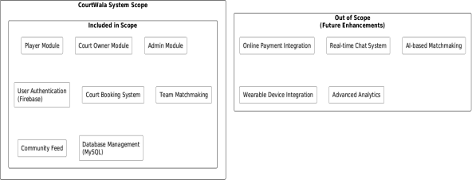

1.5 Report Organization
In this report, We have arranged the report into six chapters. Chapter 1 presents the introduction of the background, problem statement, objectives, scope, and general structure of the project. Chapter 2 includes the literature review, related work, comparison analysis and identification of the gaps research. Chapter 3 gives the explanation of the system design and methodology including the system architecture, requirements, and technologies. Chapter 4 explains about details of implementation, development environment, testing strategies and results. Chapter 5 illustrates the user interface providing screenshots and descriptions of major screens. Lastly, Chapter 6 provides a conclusion of the report, limitations of the project, and future work directions.

Chapter 2

Literature Review

2.1 Introduction
A literature review is aimed at analyzing the available research, applications, and systems concerning the proposed project to get to know about the existing solutions and gaps. Within the framework of sports court booking and community based sports websites, a number of online applications have been created worldwide to handle booking administration, organization care and coordination of players. These systems mean to substitute informal and manual systems with systematized and technological systems.
In this chapter, the author examines the available sports booking and matchmaking sites keeping a close eye on their features, strengths, and weaknesses. The review is based on the management of such systems in booking courts, team coordination, and community interaction. In a comparison of the international and local applications, this chapter shows the flaws of the current solutions, particularly in the localization and accessibility of the solution at the grassroots level. The observations of this review can be used to determine the research gap that the CourtWala will address.

2.2 Related Work
There are a few sports management and sports booking applications that have been created to simplify the game organisation process and sports facility management. An example of a popular platform is Playo where one can book sports venues, join games, and take part in sports events. Playo offers the features of venue discovery, event listings, and user profiles. Although the platform is well used in some areas, it is mainly concentrated on the larger cities and would not work well in the local sports of the community in Pakistan. Moreover, its matchmaking capabilities are also small and do not target informal or grassroots level teams.
The second local site is PlayPro, a site that provides court booking and organization of events in Pakistan. The basic features that PlayPro offers include venue booking and sports events listing. The platform however focuses more on high end facilities and structured events and it is not so friendly to small community grounds and informal teams. It also has a facility-centric user experience as opposed to a player-centric user experience.
Another sports booking system which is more interested in online court reservations and booking management is Courtsite. Courtsite provides the ability to book courts, share the bookings, and manage the schedules online. Although it is effective in the bookings, the platform does not have team matchmaking and community interaction functionalities. It fails to offer a social platform that would enable players to get teams or interact with the local sports fraternities.
Besides these purposes, scholarly studies portray the role of digital platforms in enhancing sports attendance and the use of facilities. Research demonstrates that centralized booking systems decrease the problem of scheduling conflicts, increase transparency, and lead to the satisfaction of users. Nevertheless, the majority of the current systems are centered on the booking capabilities and do not consider socialization, creation of teams, and community-oriented communication on the local scale. This is a weakness since they are not effective in areas where informal sports culture prevails.

2.3 Comparative Analysis
By comparing the current systems with the proposed CourtWala platform, it will be evident that the current systems have significant differences in scope and functionality. The available applications are mostly limited to the functionality of basic court booking and do not include an extensive approach to the community-based sports engagement.

Feature | Playo | PlayPro | CourtSite | CourtWala
Court Booking | Yes | Yes | Yes | Yes
Team Matchmaking | Limited | Limited | No | Yes
Community Feed | No | Limited | No | Yes
Localization for Pakistan | Partial | Yes | No | Yes

Based on the comparison, one can state that current platforms partially address the issue of booking but not the team coordination and interaction issue with the community. CourtWala will stand out as a product that integrates court booking, team matchmaking, and a localized community feed into one platform. Such a combination strategy would be especially adapted to the Pakistan situation in sports, where it is typical to play informally and participate in community games.

2.4 Summary of Research Gap
The analysis of the existing applications and the associated studies shows that there are some important gaps. To begin with, majority of athletic reservation sites center around venue organization and ignore the social side of sporting activities, consisting of team building and communication among the players.
Second, most of the international platforms are not localized in Pakistan and therefore are less effective when it comes to sports and participation at the community level. Third, the available local solutions are usually focused on high-end facilities and professional events, and informal players and small court owners remain unserviced.
It also does not have a unified platform to combine court booking, team matchmaking, and community engagement in a convenient and easily available way. News on tournaments, leagues and local sports events are still dispersed in the informal channels, which restricts participation and publicity. These loopholes demonstrate the necessity of a localized and detailed solution that would cater to both players and court owners and create a connected sports community.
CourtWala is suggested to fill these holes by providing a centralized mobile service that is culturally oriented to sports in Pakistan. The system will enhance accessibility, organization and involvement on the grassroots level, by offering booking management, matchmaking functionality, and a community feed.

Chapter 3

System Design & Methodology

3.1 System Overview
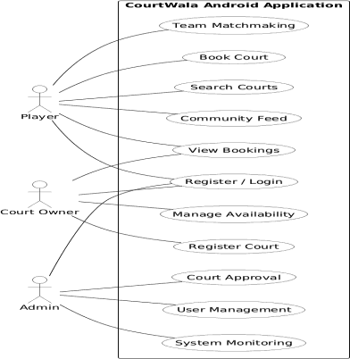
CourtWala is a mobile sports court reservation and community management application, which is meant to connect players, court owners, and administrators by using a digital platform that is centralized. The system will change the informal and manual processes into a structured, efficient, and easy-to-use solution. The app is compatible with various sports with major interests in football and cricket which are highly played in the community in Pakistan.
The architecture of the system is client server. The client side interface on which the users will communicate with the system is the mobile application developed with Flutter. The Backend Server is created with Node.js and provides RESTful API to process business logic, authentication and process data. Persistent storage of data is done with a MySQL database and Firebase provides authentication services to ensure that access by the users is secure.
There are three user roles at CourtWala. The Player will be able to search, see the availability, reserve slots, and maintain the bookings, engage in matchmaking as well as in the community feed. The Court Owner has an opportunity to create the courts, control time slots, bookings, and track the usage of the court. The Admin monitors the system, registers court and handles users, as well as facilitates the proper functioning of the platform. This role based system secures adequate accessibility and system security.
Through combining the system of court booking, match-making teams, and community integration in one platform, CourtWala aims to offer a one-stop solution to both sport lovers and club proprietors. The system is scalable, which will be expanded in the future with such features as online payments, advanced matchmaking, and analytics.

3.2 Requirement Analysis
Requirement analysis identifies the functional and non-functional needs of the system to ensure that it meets user expectations and project objectives.
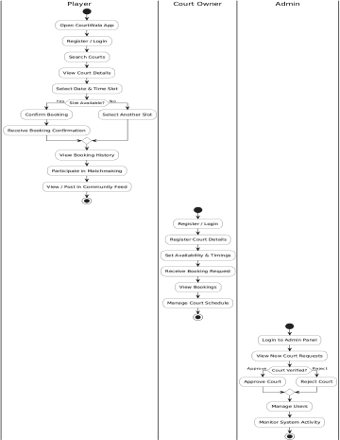

Functional Requirements

- User Registration & Authentication
  - Players and court owners must be able to register using email or phone number.
  - Profile management with personal details, preferences, and ratings.

Court Management
  - Court owners can add, edit, or delete court listings.
  - Court details include name, location, images, pricing, available time slots, and type of sport.

Booking System
  - Option to cancel bookings.

Matchmaking & Team Formation
  - Players can find others with similar interests or skill levels.
  - The system should suggest potential opponents.
  - Match requests can be accepted or declined.

Community Engagement
  - Forums or discussion boards for users to interact.
  - Option to organize local tournaments and events.
  - Chat system for players and court owners.

Admin Panel
  - Admin can monitor all bookings and disputes.
  - Admin can manage tournaments and reports and announcements.
  - Admin can suspend or block users
  - Admin can remove fraudulent users or inappropriate content.
  - Dashboard shows: Total Users Total Bookings Total Courts
  - Reports and analytics for system performance.

Notifications & Alerts
  - Push notifications for booking confirmations, cancellations, and reminders

Non-Functional Requirements
      - Performance: The app should handle at least 1,000 concurrent users without lag.
      - Scalability: The system must support expansion for more sports and regions.
      - Security: All sensitive data must be encrypted.
      - Usability: The interface should be intuitive and mobile-friendly.
      - Reliability: System uptime should be at least 99%.
      - Maintainability: Modular code structure for easier updates.

3.3 System Design Diagrams
System design diagrams are used to visually represent the structure and behavior of the system. The key diagrams used in CourtWala are described below.

System Block Diagram

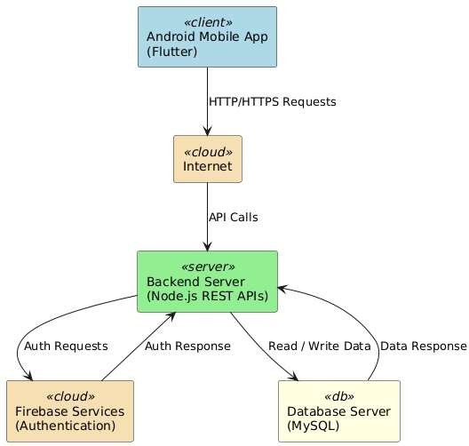

System Architecture Diagram:

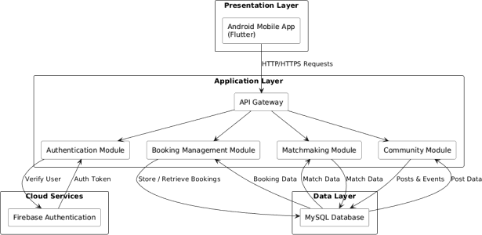

Entity Relationship (ER) Diagram

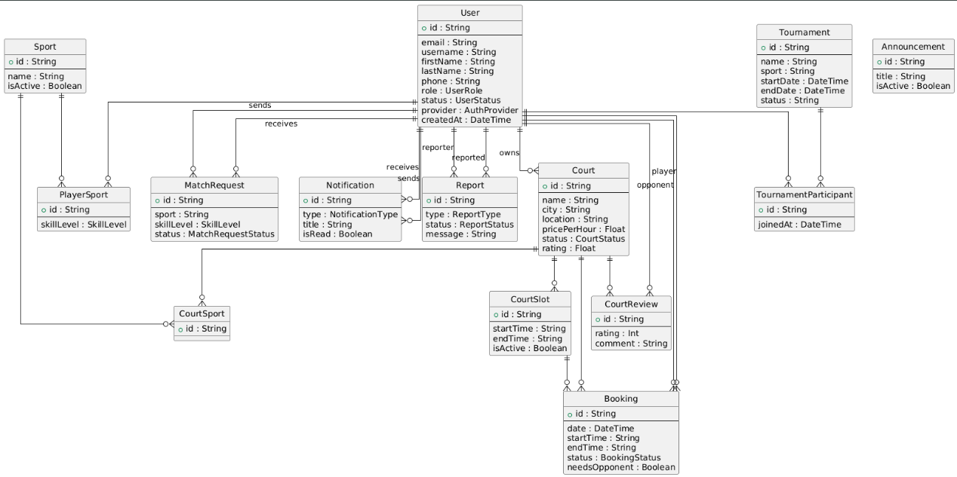

3.4 Technologies & Tools Used
here are a number of current technologies and tools in the creation of CourtWala.

- The reasons why Flutter is applied in mobile application development are that it is cross-platform, high-performance, and expressive in UI components. It allows the development of a user interface that can be smooth and responsive.

- The reason behind using Node.js to develop the backend is that it has a non-blocking nature and is applicable when it comes to working with a number of simultaneous requests. It helps in the development of RESTful APIs and it can also be easily integrated with the current databases.

- The relational database management system is MySQL which is the system where the user information, bookings, courts, and community posting are stored. It guarantees reliability of the data and its systematic storage.

- The authentication services are done on firebase where they get secure session management and user login.

RASPBERRY PI MODEL B
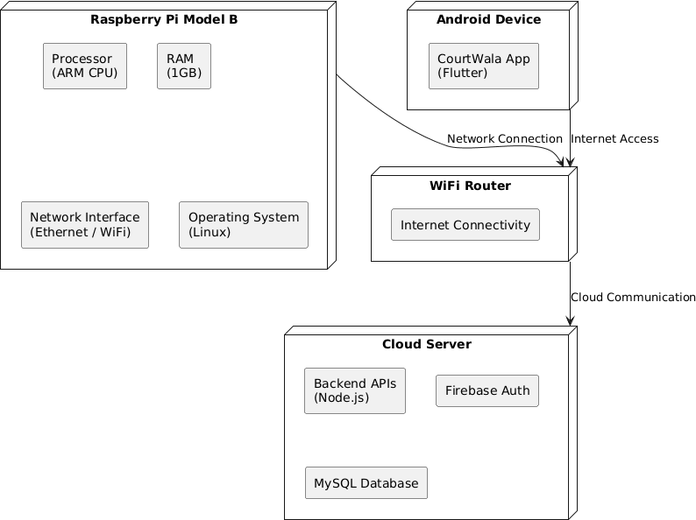
WIFI ROUTER
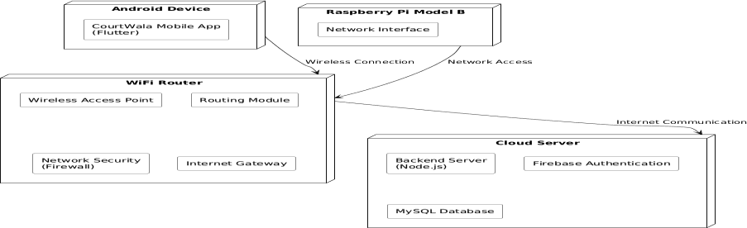
LAMP SERVER
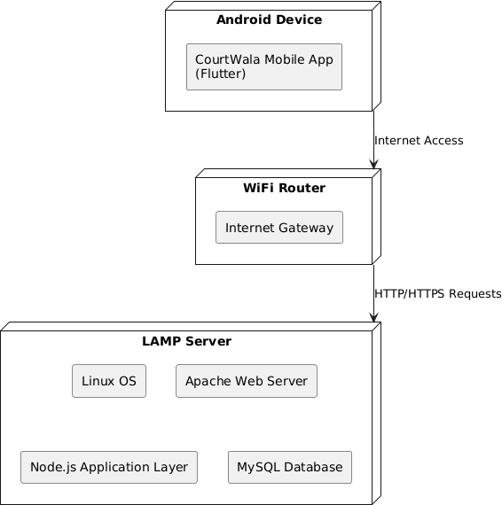

Chapter 4

Implementation & Results

4.1 Development Environment
Detail setup: IDEs, frameworks, databases, etc. [200–300 words]

4.2 Implementation Details
Describe how you implemented system modules with screenshots or code snippets. [600–800 words]

4.3 Testing Strategy
Explain testing levels: Unit, Integration, System, UAT. [300–500 words]

4.4 Test Cases
Provide detailed test cases in tabular format. [Tables + 200–300 words explanation]

4.5 Results & Evaluation
Present results, graphs and evaluation metrics. Compare with benchmarks. [500–700 words]

Chapter 5

User Interface / Demonstration

5.1 Login Interface
Screenshot + description of login page. [150–200 words]

5.2 Dashboard / Main Panel
Screenshot + description of dashboard features. [150–200 words]

5.3 Other Screens
Screenshot + description of other important interfaces. [150–250 words]

Chapter 6

Conclusion & Future Work

6.1 Limitations
List technical/functional limitations faced. [150–200 words]

6.2 Conclusion
Summarize project outcomes and learning. [200–300 words]

6.3 Future Directions
Suggest improvements and extensions for future work. [200–300 words]

References
References should follow IEEE or APA style.

Appendices
Appendix A: Source Code Snippets
Appendix B: Gantt Chart / Project Timeline

